# PeopleSafe - Obtaining an Email Address and Managing Messaging Platform Alerts

Setting Up and Removing Messaging Preferences (MP)

Troubleshooting

Setting Document Preferences (Medicare D Only)

Obtaining an Email Address

Communication History (Messaging Platform and Consolidated Communications)

Frequently Asked Questions

Turnaround Time

Related Documents

**Description:** Information and procedures to Optimize Communication Preferences and includes the instructions on how to set up the Messaging Platform for the member including obtaining email addresses.

|  |
| --- |
| Setting Up and Removing Messaging Preferences (MP) |

Messaging Platform (MP) is available for every plan member, although clients may dictate specifics regarding alerts and channels. The default method of contact (channel) may be a phone call or email, but the member can change the channel or opt out by contacting Customer Care or accessing our web portal.

For a description of each alert, refer to [Messaging Platform Alerts (110103)](https://thesource.cvshealth.com/nuxeo/thesource/#!/view?docid=d3dcf7c9-3cc9-4864-b6c1-165416474fa1).

Only [maintenance medications](https://www.caremark.com/portal/asset/CVS_Caremark_Maint_DrugList.pdf) are eligible for Refill Reminder alerts.



**MED D Only:** Has the capability to set preferences for members via Email or Mail channels (Refer to Setting Document Preferences).

Our system allows members to enroll in all Messaging Preference channels instead of being restricted to just one channel per Message Type. This provides more flexibility for us to deliver the most effective message via the best channel for the member at the time of the communication.

**Example:** A lower priority informational message could be sent by email and a higher priority message requesting the member to take action could be sent via text.

Prior to sending a message, MP reviews the communication channels where the member is enrolled and will pick the best channel to send that specific message. Only one channel is used to deliver a given message at a time.

**The** **Contact Info screen in PeopleSafe includes options to:**

* Enroll a member in multipleMessaging Preference channels (**Example:** Email, Text, Call and/or Secure Inbox on the Member Website).
* Turn on (add check in box) or off (remove check from box) Messaging Preference channels per Program.
* Opt Out member from that individual Messaging Platform (MP) channel.

To set up and remove messaging preferences refer to the following:

|  |  |  |  |
| --- | --- | --- | --- |
| **Step** | **Action** | | |
| **1** | Confirm contact information on file is accurate with the caller. If contact information is missing, or needs updated, see table below.   * If all contact information is accurate, and Messaging Platform (MP) alerts are already enrolled, no action is necessary.   Anyone who is fully authenticated and is authorized to order a refill for a member can set up the [Messaging Platform Alerts (110103)](https://thesource.cvshealth.com/nuxeo/thesource/#!/view?docid=d3dcf7c9-3cc9-4864-b6c1-165416474fa1). However, **ONLY** the member or POA/Authorized Representative with paperwork on file can make changes to account details, such as the phone number or address.  Refer to [PeopleSafe - Address, Email and Phone Number Changes 9004566)](https://thesource.cvshealth.com/nuxeo/thesource/#!/view?docid=a09925d4-9dbb-407b-b579-c17eec6e62ee) or [MED D - Email and Phone Number Changes (112972)](https://thesource.cvshealth.com/nuxeo/thesource/#!/view?docid=e0799360-70cd-4d44-a8b0-3112e61449f3) and/or [MED D - Address Changes and Out of Area (OOA) (030149)](https://thesource.cvshealth.com/nuxeo/thesource/#!/view?docid=0ba6dea9-4b34-4351-b06a-ec81046f6c0f). | | |
| **If…** | **Then…** | |
| Phone number to call not on file or needs updated | 1. Ask for the best phone number for us to call (for instance, to give status updates on their orders). 2. Add the phone number. 3. Check if other contact information needs updated. 4. After all contact information is updated, proceed to next step.   **Note:** Any valid phone number can be used for call notifications. | |
| Mobile (cell) phone not on file or needs updated | 1. Ask for the cell phone number.  2. Add the cell phone number.  3. Check if other contact information needs updated.  4. After all contact information is updated, proceed to next step.  **Note:** A valid cell phone number must be used for text notifications and be labeled in our system as a cell phone. | |
| Email not on file or needs updated | 1. Ask for the email address.  2. Add the email address.  3. Check if other contact information needs updated.  4. After all contact information is updated, proceed to next step. | |
| **If…** | **Then…** |
| **Do not ask for email address** is already selected on profile | Remove this selection. |
| Member specifically asks us not to ask them about their email address in the future | Refer to **Procedural Transfer** in the [PeopleSafe - When to Transfer Calls to the Senior Team (016311)](https://thesource.cvshealth.com/nuxeo/thesource/#!/view?docid=9eef064d-c7d7-42f7-9026-1497496b4d51) or [MED D - When to Transfer Calls to the Senior Team (018060)](https://thesource.cvshealth.com/nuxeo/thesource/#!/view?docid=d3ca13af-f894-45b7-b16a-f2cb777adf77)to place a permanent Stop See Comment on the member’s account. |
| Member is not registered on Caremark.com or shows “Inactive/Winback” | Refer to [Quick Registration for Caremark.com (012470)](https://thesource.cvshealth.com/nuxeo/thesource/#!/view?docid=c90a32de-421f-42c2-8d5c-69ce36571418). |
| **2** | Review the Messaging Preferences, select a valid phone number and/or email address using the Enrollment Status dropdown menu, and click **Update Channel**.  **Result:**  Available Programs are selected automatically except for those designated as “opt in only.”  CCRs Should ask the member if you can enable messaging preferences. CCRs should set up messaging preferences once phone number, text number, and/or email address are verified. Then proceed to ask member which notifications they prefer to be enrolled in.   * For **text** alerts, the following statements MUST be provided: * You will receive a welcome message to the cell number you provided within 15 minutes. Please note, message and data rates may apply. Check with your carrier for more information.  * You can reply STOP to opt-out. For help or more information, call the number on the back of your ID card.  * Message frequency is based on account activity. To review the full list of terms and conditions and privacy policy, please click the link in the welcome message. Follow the instructions in the message to complete the confirmation.  * If you do not receive the welcome message, please contact us at the number on the back of your ID card. Just a reminder, depending on your data plan with your mobile service provider, you may be charged for these text messages.  * For **call** alerts, the following statement MUST be provided: * You are consenting to receive benefit-related automated messages. You may revoke consent at any time.   **Note:** If a phone number or email address displays in red font, it is flagged as Invalid and alerts are disabled for that channel. A new phone number or email address should be selected, or the Invalid indicator can be cleared by clicking the **Reset** button in the corresponding section of the Maintain Address screen.   * Sometimes email addresses and phone numbers may show as invalid even though they are not. Failed attempts to contact a member via that channel will cause invalid indicators. The invalid indicator is cleared by clicking the **Reset** button in the corresponding section of the Maintain Address screen. * Email addresses are flagged as invalid if recent email messages are caught in spam filters or the message “bounces.” * **Example:** The message is rejected by the provider as undeliverable. * Phone numbers are flagged as invalid if the phone is disconnected, busy, or does not have voicemail. MP attempts to contact members two times via phone before flagging a phone number as invalid.   Do not proactively offer to review the Programs list or opt members out of a certain Program’s communications.    **Notes:**   * If a Program checkbox is grayed out, alerts are not available via that channel. * The Payment Notifications Program is only available through the Email and/or Secure Inbox Channels. If the member indicates they do not want to receive communications about certain programs, advise them that they are able to update their messaging preferences and make program-specific changes.   When the member’s Messaging Preferences have been updated successfully, the following confirmation message displays. Click **OK** to return to the **Contact Info** screen.    **Result:** After clicking **OK** on the confirmation message, the Contact Info screen displays with the Messaging Preferences refreshed. All available Programswill be automatically selected for the newly enrolled Channel(s) except for those designated as “Opt In only.”    The following information is required for each channel:   * **Email:** Valid Email Address * **Text:** Valid Phone Number without an extension * **Call:** Valid Phone Number without an extension   **Notes:**   * For outbound calls, the member’s zip code listed under the Primary Home address is used to determine local times. * For text messages, there are no limits set on time of day. They are received at any hour. * The member will need to “Opt In” to the Full Drug Name program or they will only receive abbreviation of Drug name. The Fully Drug name option is only available via Email only.   The Enrollment Status for each Channel (Email, Text, Call) displays one of the following:   * **Select One:** The member is not enrolled in the communication channel. * **Member Opted Out:** The member has previously chosen not to receive communications via the channel. * **Not Available:** The client does not allow communication through the channel. * **Member Email Address** or **Member Phone Number:** The member has previously enrolled to receive communications via the channel.   Using the **Clear** button under Programs will remove all program selections.  **Notes:**   * When a member enrolls in a communication Channel, all Program alerts will be selected by default except for those designated as “Opt In only.” * No PHI is disclosed in MP alerts unless the member “Opts In” to the Full Drug Name program. This can only be done via EMAIL only. The copies of MP alerts sent to the member’s Secure Inbox on the member website (if that option is selected) may contain PHI. * Members can make and update these selections on the Communication Preferences screen of our web portal. | | |
| **3** | Assist the member with their messaging preferences and educate on the benefits of MP (Messaging Platform) alerts.  If the member specifically states they would like to remove a messaging preference, you may assist the member with either removing that preference entirely or editing that messaging preference to add/remove specific alerts.  **Important Reminders:**   * **Do not** proactively offer to review/remove messaging preferences. Only remove/reduce messaging preferences if the caller requests. * Anyone who is fully authenticated and authorized to order a refill for a member can set up the [Messaging Platform Alerts (110103)](https://thesource.cvshealth.com/nuxeo/thesource/#!/view?docid=d3dcf7c9-3cc9-4864-b6c1-165416474fa1). However, **only** the member or POA/Authorized Representative with paperwork on file can make changes to account details, such as the phone number or address.   Refer to [PeopleSafe - Address, Email and Phone Number Changes (004566)](https://thesource.cvshealth.com/nuxeo/thesource/#!/view?docid=a09925d4-9dbb-407b-b579-c17eec6e62ee) or [MED D - Email and Phone Number Changes (112972)](https://thesource.cvshealth.com/nuxeo/thesource/#!/view?docid=e0799360-70cd-4d44-a8b0-3112e61449f3) and/or [MED D - Address Changes and Out of Area (OOA) (030149)](https://thesource.cvshealth.com/nuxeo/thesource/#!/view?docid=0ba6dea9-4b34-4351-b06a-ec81046f6c0f).   * **To Unenroll/Disenroll:** If the member requests to disenroll from a certain program, locate the program name in the Messaging Preferences section and uncheck the box that corresponds to the program and communication type. After you uncheck the appropriate box, click the **Update Program** button. * **To Enroll in Messaging Preferences for the “Full Drug Name”:**  1. Select option for **Email** (member’s email), **Text** (member’s cell phone), **Call** (member’s telephone number displayed) and/or Secure Inbox (located on our website) boxes.   If you are speaking to someone other than the member, the **caller must have** a completed Third-Party Authorization (TPA) or Power of Attorney (POA) form on file, or verbal permission from the member must be obtained to update the Full Drug Name messaging preference (This option is only availed via email only). **No exceptions.**   * Preference is to select all options and our system determines which option has the best response rate for each type of contact.  1. Click on **Update Program.**   **Note:** If a Program does not display in the Messaging Preferences **Programs** list, it is not available for the client. | | |
| **4** | Educate the member about the option to update their messaging preferences in the future using the Communication Preferences section on Caremark.com.  **Note:** Not all clients utilize Caremark.com (though most do), check the CIF to ensure member’s plan participates in Caremark.com. | | |

Top of the Document

|  |
| --- |
| **Troubleshooting** |

**Issue:** Member receives "Update Needed! Alert contact information is outdated or incorrect. Click here to correct your contact information for important our Home Delivery / Mail Order Alerts."

**Action:** Update their phone and/or email information as indicated in Step 2 of the Setting up Messaging Preferences section in this document.

 If a member is not receiving the alerts and agent has verified the correct contact information, then reach out to senior team and have an IT ticket submitted.

Top of the Document

|  |
| --- |
| Setting Document Preferences (Medicare D Only) |

Clients can opt into the Digital Enablement System (DES). This will drive beneficiaries toward a digital form of paperless document consumption. For the clients that have opted in, CCRs can assist beneficiaries in setting preferences for documents in the DES.

 No documents have been added for any client. Until the documents have been set up for a specific client, the following error displays when accessing the Document Preference button: “Documents are currently not available for this member to set the preferences.”

* Under the Change Info screen, a **Document Preferences** button displays.
* Once that button is selected, the Document Preferences will expand, and various documents will populate that are available to the beneficiary including:
  + Annual Notice of Change
  + Direct Bill Invoice
  + Welcome Kit Change
* You will have the capability to set preferences for beneficiaries via Email or Mail channels for each individual document or by clicking **Select All**.
  + When clicking on **Select All** for Email (Paperless) or Mail (Paper), the top radio button will set document preferences delivery channel for all current and future documents, including EOBs (Select All is what we call our Global Flag in DES).
  + When **Select All** radio button for Email or Mail is **not** selected, individual DES document preferences will be set according to selections on the screen.

**Note:** Future documents are set as Mail (Paper) since our Global Flag is not set for document preferences. EOB’s preferences will not be updated.

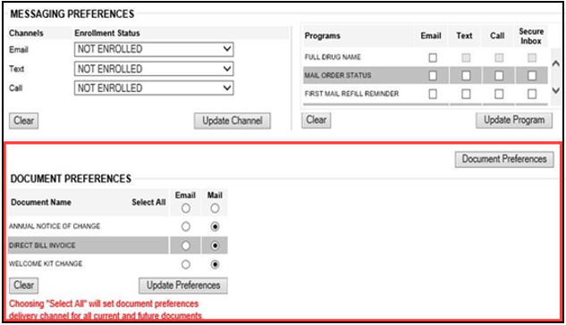

 There is a very small chance that the update might fail in one system. To help Production Support quickly pinpoint an issue in a specific system, we are enhancing error messaging to include the name of a failed system in parenthesis after the error message (RxClaim or QL or DES). If an error message is received, contact your Supervisor for assistance with opening an IT ticket.

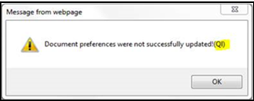

Top of the Document

|  |
| --- |
| **Obtaining an Email Address** |

This section provides instructions for obtaining an email address for our members. Having a current and accurate email address on file will ensure the member receives notifications about their account and Mail Order prescriptions.

**Examples:** Email notifications include those available through the Messaging Preferences.

* **Order Status** 
  + Notify me when there is a problem with my order.
  + Notify me when my order is held due to early refill.
  + Notify me when my order is received.
  + Notify me when my order is shipped.
* **Refill Reminder** 
  + Notify me when I have a refill available.
  + Notify me when I have no refills left.
  + Notify me when my refill is about to expire.

Perform the steps below:

|  |  |  |
| --- | --- | --- |
| **Step** | **Action** | |
| **1** | Review the **E-mail** field on the PeopleSafe Main screen or on the Change Contact Information screen.    At an appropriate time during the call, ask the member if you may add/confirm their email address.   * Can you please confirm the email address on your account? * I definitely want to ensure you stay informed about your medication orders; can you please confirm your email address?   Great times to ask for an email address:   * Directly after HIPAA authentication as part of your call flow * When placing a refill or checking order status * While updating an address or telephone number * While providing education about plan benefits or mail service   **Effective immediately:** After adding an email address, if the member is not registered on Caremark.com (and the plan participates in Caremark.com, check the CIF), **DO NOT** ask the member if they would like to register. Simply proactively send them the quick registration link to Caremark.com and educate the member.   * Great, thank you for confirming your email! We’ve sent you a link to help you register on Caremark.com so that you can stay empowered and informed about your prescription plan. The link will allow you to quickly register on Caremark.com for the next 72 hours.   Educate on benefits of Caremark.com that are relevant to the reason for their call, such as:   * Tracking Mail Order deliveries * Refilling anytime online * Checking the costs of your prescriptions * Locating any in-network pharmacies near them | |
| **If the email field...** | **Then...** |
| Is blank | Ask member if they would like to add their email address. |
| Has an email address listed | Send member the quick registration link and educate on caremark.com. |
| Indicates: Do Not Ask for email or similar | The member may have previously indicated that they do not have an email address to share.   * Acknowledge this but attempt to update this information.   **Example:**  I see you previously did not have an email address to provide. Do you have one we could add today for messaging alerts about your orders?   * If the member does not want to be asked for the email address, refer to **Procedural Transfer** in the [PeopleSafe - When to Transfer Calls to the Senior Team (016311)](https://thesource.cvshealth.com/nuxeo/thesource/#!/view?docid=9eef064d-c7d7-42f7-9026-1497496b4d51) or [MED D - When to Transfer Calls to the Senior Team (018060)](https://thesource.cvshealth.com/nuxeo/thesource/#!/view?docid=d3ca13af-f894-45b7-b16a-f2cb777adf77)to place a permanent Stop See Comment on the member’s account.   **Note:** Please do NOT check the box for “Do Not Ask For E-Mail. |

Top of the Document

|  |
| --- |
| **Communication History (Messaging Platform and Consolidated Communications)** |

Communication History screen offers two views to access messages sent to the member.

You have the option to view messages sent through the View Digital Communications (which will only show messages sent through the Messaging Platform) or view a comprehensive list under the Consolidated View, which includes all correspondence sent to the member, digital or otherwise. The information will vary based on the type of correspondence sent: E~~-~~mail, phone call, text, letter, etcetera.

Message Platform Communication History is accessible via Digital Communication Button for both **Commercial** and **MED D**.

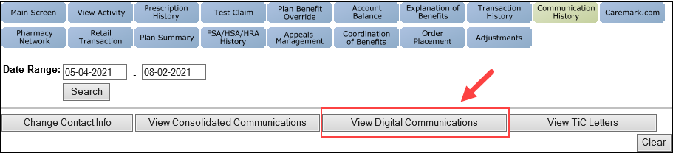

**Note:** Depending on the message preferences in which the member has been enrolled, the digital communication history will list all notifications sent to the member about the status of their order.

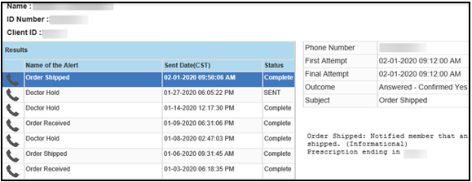

**View Digital Communications**

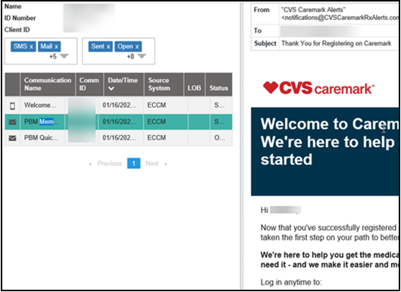

**View Consolidated Communications**

**Note:** This provides the ability to filter the information through the drop-down arrows for both message type and status. Select the check box to choose the type of message and the status of the correspondence to view.

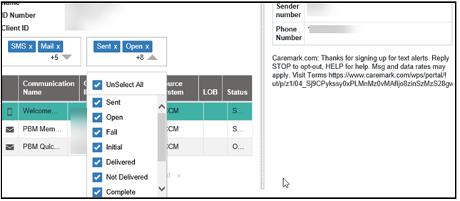

**Message Status filter option**

Top of the Document

|  |
| --- |
| **Frequently Asked Questions** |

**Note:** PeopleSafe automatically documents the change on the View Activity screen when email addresses are updated.

Refer to as needed:

|  |  |  |
| --- | --- | --- |
| **#** | **Question** | **Answer** |
| **1** | **Why should I enroll in Messaging?** | With Messaging, the key benefits are:   * You can receive important updates by text, email, and call. * Messages are sent in ‘real time’ using the best available channel to send each message. * Better service from Customer Care, who will have access to a single source of up-to-date information about the important messages you are receiving. |
| **2** | **Do I have to “sign up” or register for Messaging, or am I automatically included?** | I can definitely help you enroll in Email, Text, and Call communications now. You can also manage your own preferences at any time by accessing the secure member website at our Home Delivery/Mail Order pharmacy portal. |
| **3** | **Why would I want to enroll into multiple communication channels?** | Enrolling in multiple channels gives our Home Delivery/Mail Order pharmacy the flexibility to communicate to with you in the best way possible both for today’s programs and for future programs. Our system will automatically choose the best way to alert you, and you will not get the same alert across each messaging option. |
| **4** | **If I am enrolled in more than one channel, will I get duplicate messages?** | No. If you are enrolled in more than one channel, we will choose the best way to deliver each alert, so you do not get duplicates.  Longer ’information only’ messages are sent via email.   * Messages that need a timely response or are intended for real-time updates will be sent via text or call. |
| **5** | **Do I have to pay more to enroll in Messaging?** | No. There is no additional cost to you. However, if you select the text message option, standard text messaging rates will apply (as charged by your cell phone company). |
| **6** | **How does the Messaging system (MP) work?** | Basically, the process is as follows:   * The Messaging system communicates with other Home Delivery/Mail Order pharmacy systems and is notified in near real time when certain events occur.   **Example:** Your refill is available, order has shipped, etcetera.   * The Messaging system analyzes the event, checks your messaging preferences, and sends you the appropriate message. * At about the same time, your message history is updated with Customer Care so that our representatives will have access to the message if/when you have a question about it. |
| **7** | **What if I don’t have e-mail or a cell phone?**  **How will I receive these messages?** | If you want to receive messages but you do not have a cell phone for text messages or Internet access for e-mail, you can call us anytime, and we’ll be happy to update your Messaging Preferences. We can definitely ensure you’re setup for call messages to stay up to date with your medications. |
| **8** | **Can I make changes to my preferences at any time?**  **For example, if I want to receive text messages then later decide that I prefer e-mail, or**  **I want to “opt out” then later decide I want to “opt in.”** | Yes. You can make changes to your preferences at any time by using our secure member Home Delivery/Mail Order pharmacy website or by contacting Customer Care to make the changes for you. |
| **9** | **Am I able to receive a text message for one message type and an automated voice message for another message type?** | Yes, you can customize your messaging experience by enabling or disabling channels for a specific program.   * You can log on to our secure member Home Delivery/Mail Order pharmacy website and update your messaging preference selections on the **Communication Preferences** screen. |
| **10** | **What about privacy?**  **If more than one person in a household is receiving messages, how does CVS Caremark keep my messages private?** | This has been carefully considered by our Home Delivery/Mail Order pharmacy.  None of the Alerts (regardless of format) or other messaging will violate any privacy laws. The messages do not reveal specific information about your medications, health conditions or other protected health information in a non-secure way unless you specifically request it.  In addition, for specific messages, additional identification is required before the complete message is provided (e.g., the person who answers the phone will be prompted to give a date of birth and prescription number before the refill process proceeds).   * No PHI is disclosed in SMS 2-Way text message or phone alerts. * Copies of alerts sent to the member’s Secure Message Center (if that option is selected) do contain PHI. |
| **11** | **Who is our contact if we have questions about the Messaging system (MP)?** | If you have questions about the Messaging Platform (MP), please contact us by dialing the toll-free number on the back of your identification card. |
| **12** | **Can I have alerts sent to me and others on my account?**  **Example:** Spouse, dependent child and POA, etcetera, sent to the individual phone or email address. | Multiple members can receive alerts for the member if their individual phone numbers are added to their Communication Preferences on the secure our Home Delivery/Mail Order member website.  Anyone who is fully authenticated and authorized to order a refill for a member can set up alerts. However, **ONLY** the member (or a POA, Legal Guardian, or Legal Conservator) can request the phone number or email address to be changed on their account.   * To protect patient privacy, the caller must positively identify the email address or phone number in PeopleSafe. * If needed, ask if the member is available to give **verbal permission** so that the changes can be made during the call. * If unavailable, the member can call back or update their individual address on our secure member Home Delivery/Mail Order pharmacy website. * Refer to [HIPAA (Health Insurance Portability and Accountability Act) Grid - CVS (028920)](https://thesource.cvshealth.com/nuxeo/thesource/#!/view?docid=5b354e50-0d15-42d0-b9c2-0711ea02d9ce) to determine who is authorized to request a refill on behalf of the member. * The member can set up alerts (for dependents under age 18 only) on our secure member website. Refer to [Caremark.com – Update Profile – Customer Care (038104)](https://thesource.cvshealth.com/nuxeo/thesource/#!/view?docid=90c8be08-51d0-4c28-ac12-010337674133). * For **verbal permission**, the representative should ask to speak to the member whose information the caller is requesting to update. Once the member is on the phone, ask if we have permission to speak with the caller on his or her behalf and/or to change the email address or phone number as requested. * If the member states **yes**, thank the member for his or her time. You can advise that the member may now give the phone back to the original caller and continue with the changes. * If the member states **no**, do not continue with the changes.   **Note:** No PHI is released within these alerts. The only messages that will always contain PHI are the copies of alerts placed in the member’s Secure Message Center mailbox, which is accessible only through their profile on our secure website. |
| **13** | **What if I am receiving alerts and want to stop them?** | That is easy to do! There are three ways to stop or turn off messages:   * You can log on to our secure member web portal and update your messaging preference selections on the **Communication Preferences** screen. You can unselect a category of alerts or, you can ‘opt out’ of a communication channel altogether. You can turn alerts back on at any time. * You may choose the convenient ‘opt out’ option provided each time a call is made. * You may ask Customer Care to turn off the messages. |
| **14** | **I am receiving misdirected or incorrect alerts/automated phone calls, or I want to be added to the “Do Not Call” list.**  **Can I stop alerts/automated phone calls?** | Yes. We can remove your phone number from our outbound calls list. Allow me to submit the request for you.   * Refer to [Do Not Call (DNC) RM Task Request – CCR (009294)](https://thesource.cvshealth.com/nuxeo/thesource/" \l "!/view?docid=33bdcd98-90e2-4049-a3fc-9aea495258a6).   **Note:** Review the member’s profile and update the phone number on file if needed. Refer to:   * [PeopleSafe - Address, Email and Phone Number Changes (004566)](https://thesource.cvshealth.com/nuxeo/thesource/#!/view?docid=a09925d4-9dbb-407b-b579-c17eec6e62ee) * [MED D - Email and Phone Number Changes (112972)](https://thesource.cvshealth.com/nuxeo/thesource/#!/view?docid=e0799360-70cd-4d44-a8b0-3112e61449f3) * [MED D - Address Changes and Out of Area (OOA) (030149)](https://thesource.cvshealth.com/nuxeo/thesource/#!/view?docid=0ba6dea9-4b34-4351-b06a-ec81046f6c0f) * [PeopleSafe - Calling Issues Messaging Platform or Automated Outbound Calls CCR (023458)](https://thesource.cvshealth.com/nuxeo/thesource/#!/view?docid=c404f368-6d11-4dca-8bc6-40c793120335). |

Top of the Document

|  |
| --- |
| Turnaround Time |

Immediate

Top of the Document

|  |
| --- |
| Related Documents |

 [PeopleSafe - Calling Issues Messaging Platform or Automated Outbound Calls and Do Not Call (023458)](https://thesource.cvshealth.com/nuxeo/thesource/#!/view?docid=c404f368-6d11-4dca-8bc6-40c793120335)

[Log Activity/Capture Activity Codes (005164)](https://thesource.cvshealth.com/nuxeo/thesource/#!/view?docid=bdac0c67-5fee-47ba-a3aa-aab84900cf78)

[Customer Care Abbreviations, Definitions, and Terms Index (017428)](https://thesource.cvshealth.com/nuxeo/thesource/#!/view?docid=c1f1028b-e42c-4b4f-a4cf-cc0b42c91606)

[Two Way SMS Text Messaging (002972)](https://thesource.cvshealth.com/nuxeo/thesource/#!/view?docid=af1084cd-8af3-41d1-a229-864c80ef747f)

**Parent Document:** [CALL 0049 Customer Care Internal and External Call Handling](https://policy.corp.cvscaremark.com/pnp/faces/DocRenderer?documentId=CALL-0049)

Top of the Document

Not to Be Reproduced or Disclosed to Others without Prior Written Approval

**ELECTRONIC DATA = OFFICIAL VERSION / PAPER COPY = INFORMATIONAL ONLY**